Finalization of designs:

Menu:

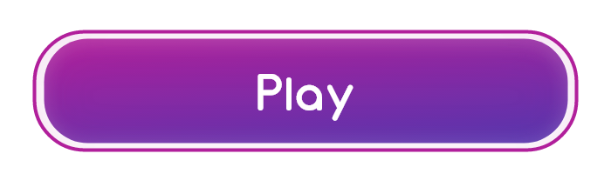



Hover buttons: these are ok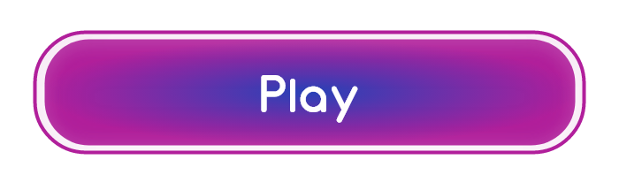

Sea Edge menu below is ok to proceed

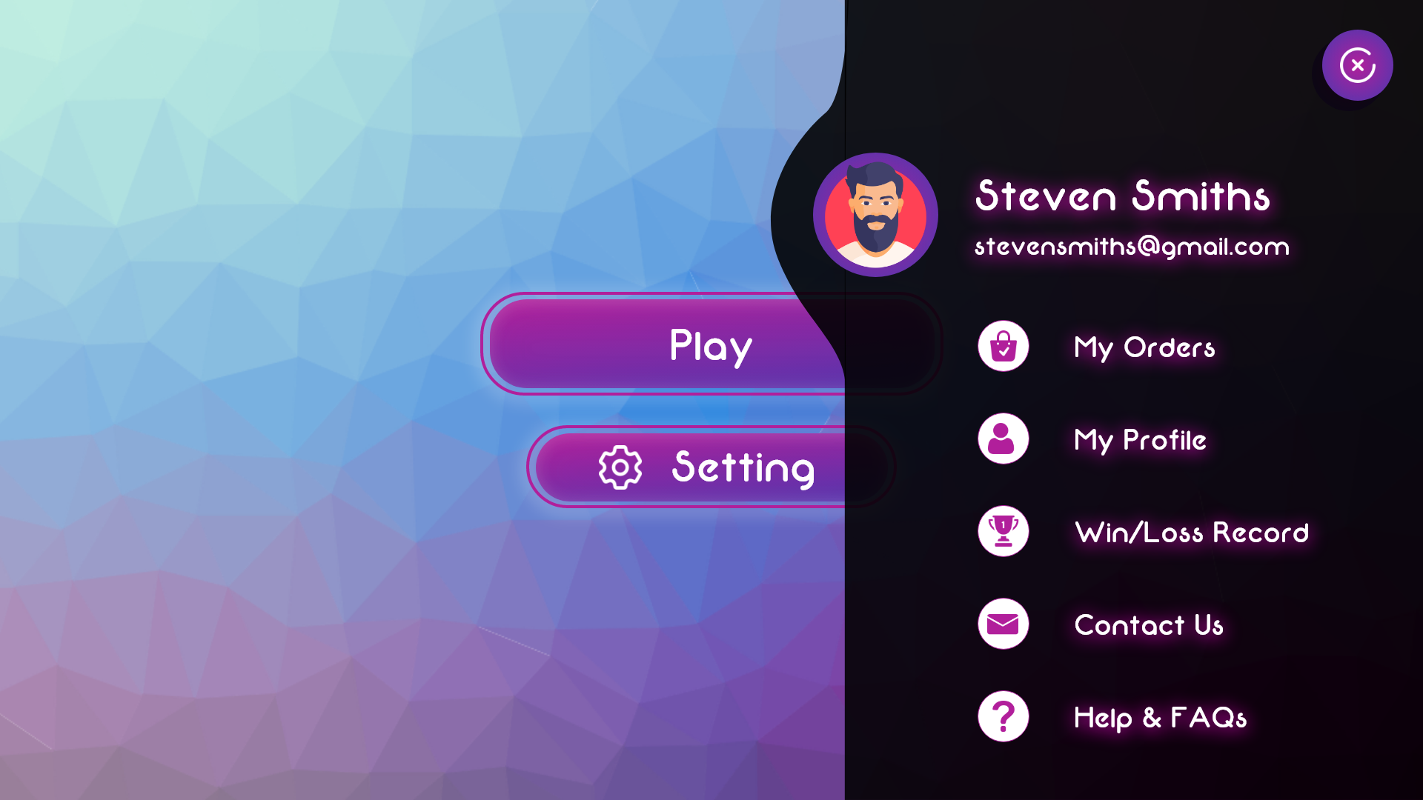

Web menu button ok

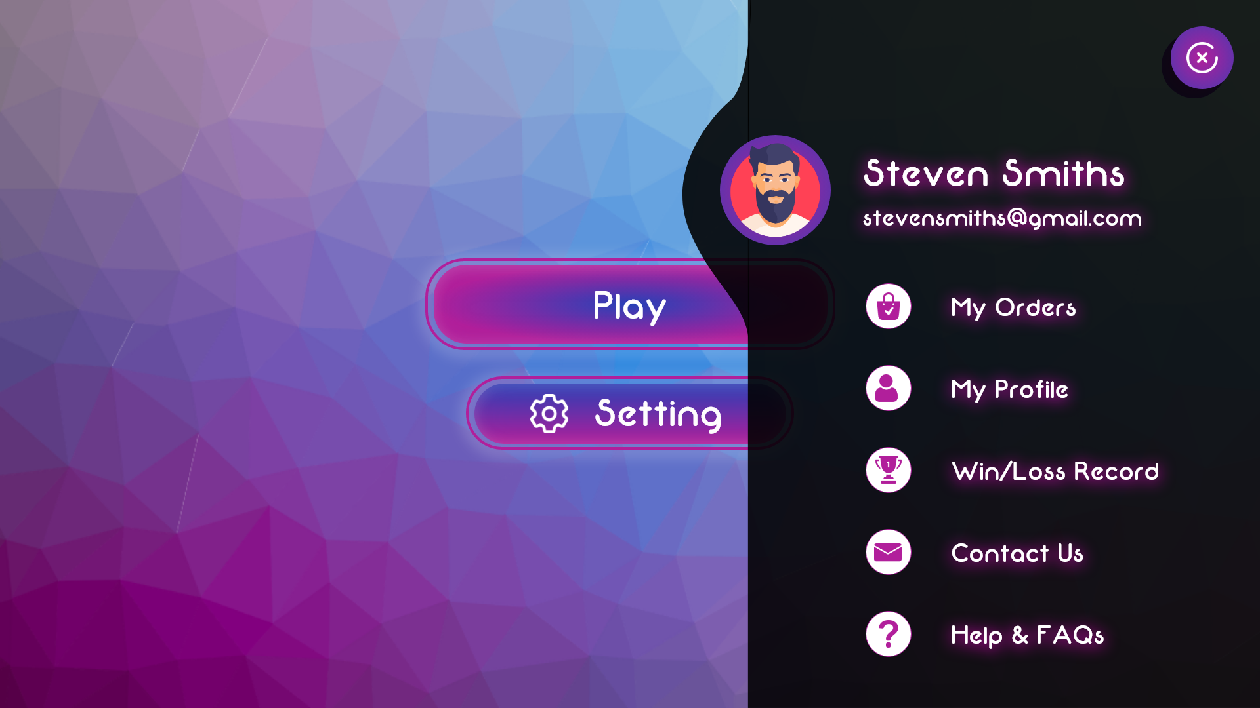

Web menu hover is not bright enough to show which is being selected just a small adjustment

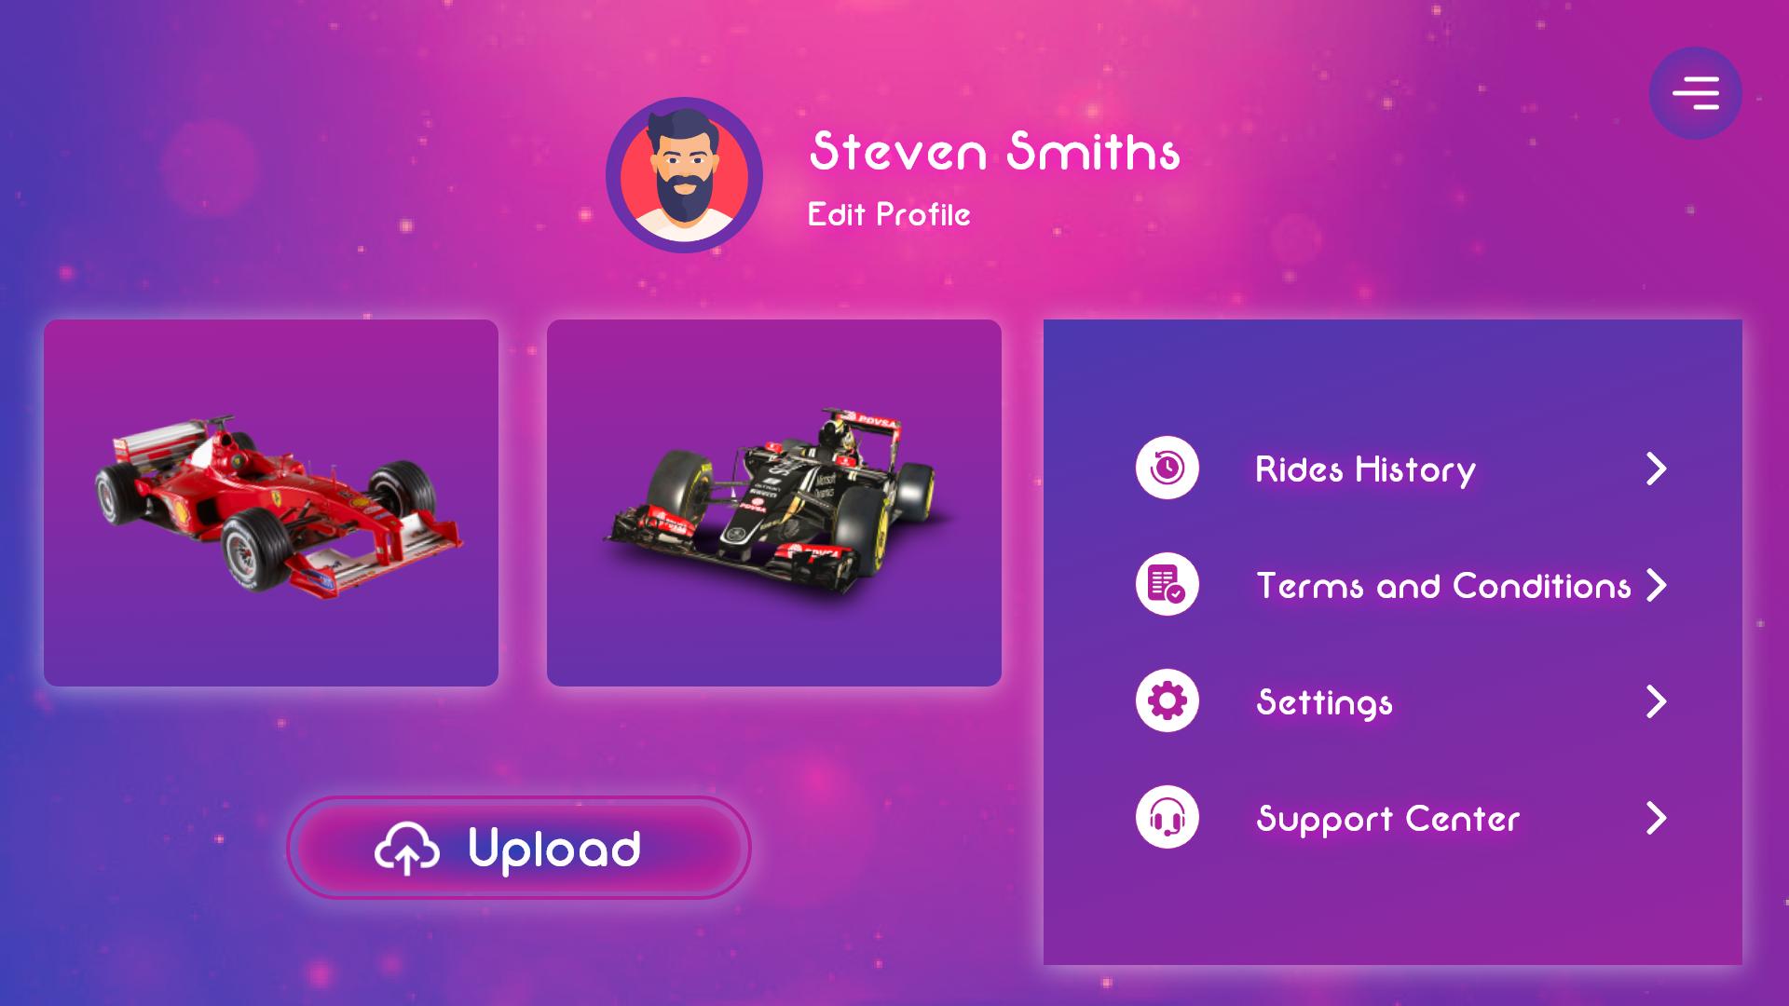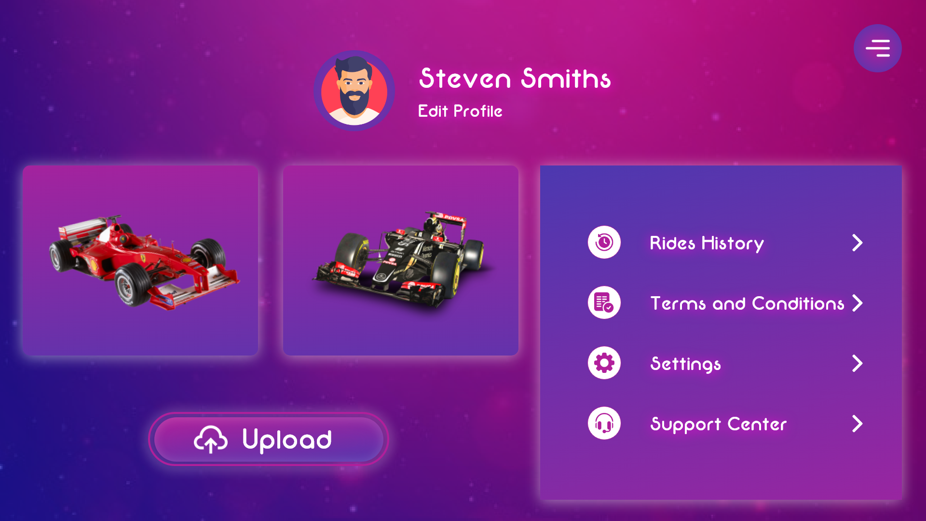

Web menu background is ok

Vehicles:

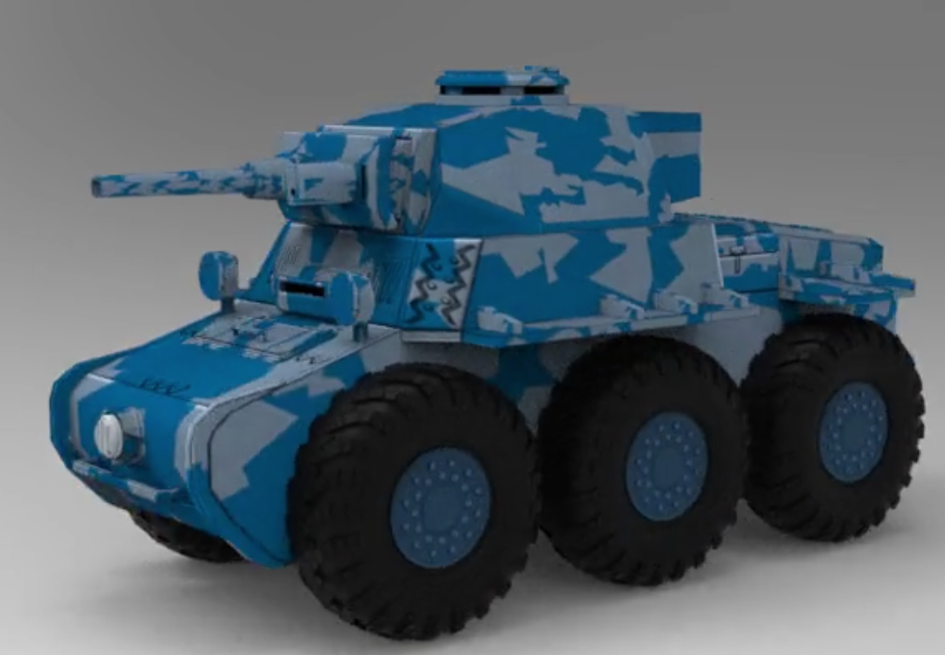

This tank is good to go

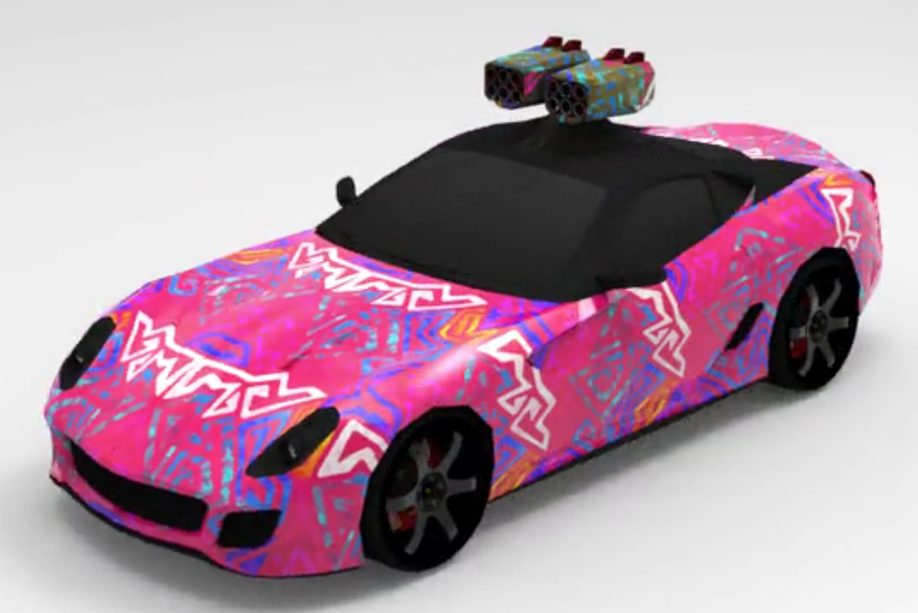

This pink car is good to go as well

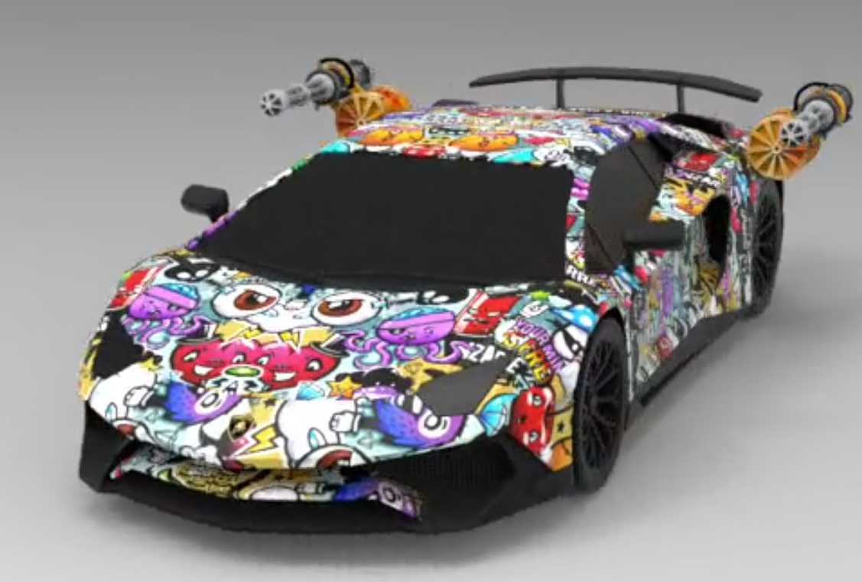

The lambo is excellent and is approved to proceed

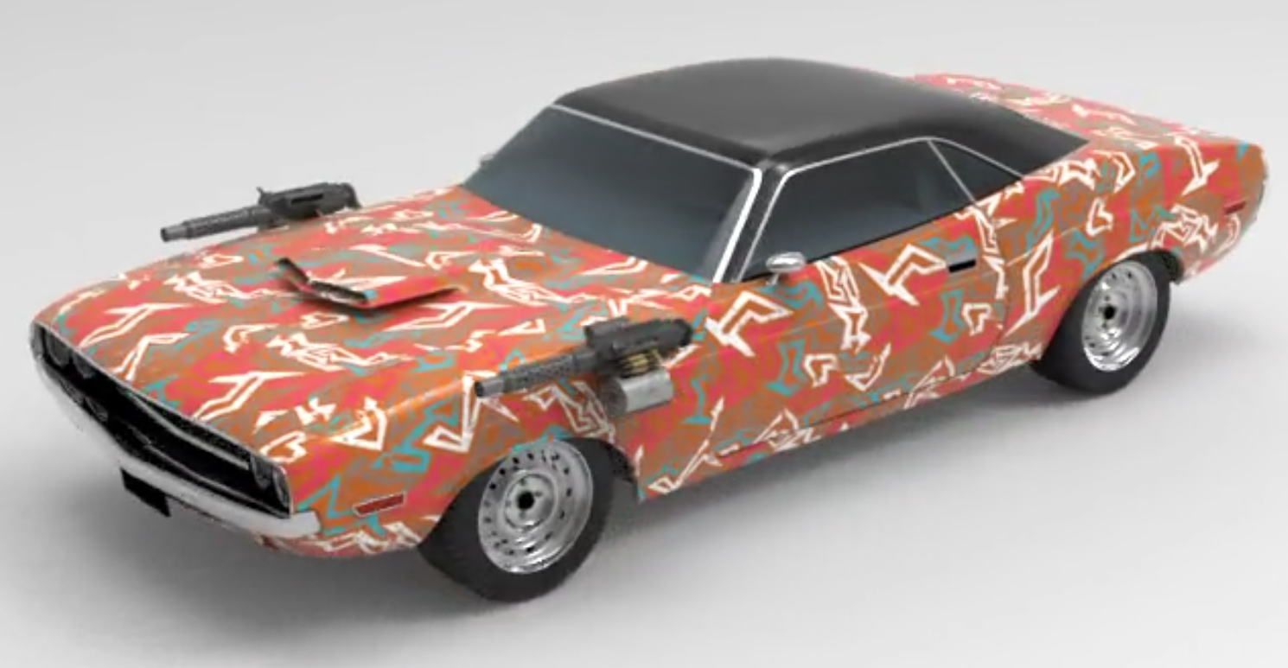

Muscle car is ok to proceed